**TASK-6 :**

**Sales Trend Analysis Using Aggregations**

**Step 1: Create a Database**

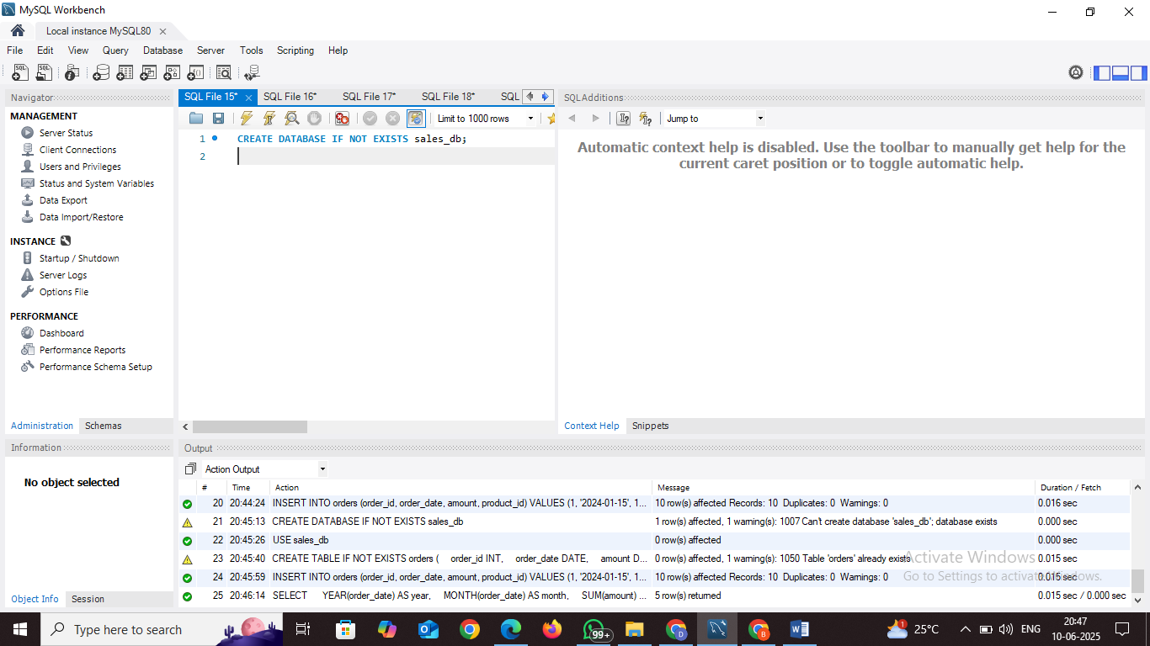

**Step-2: Use the Database**

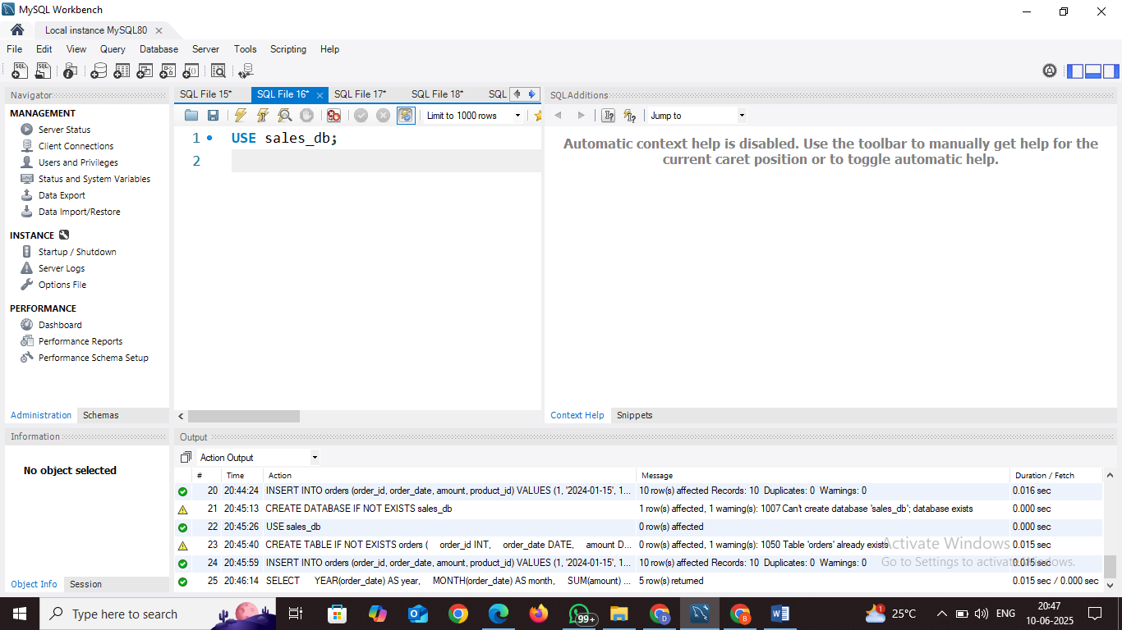

**Step 3: Create the orders Table**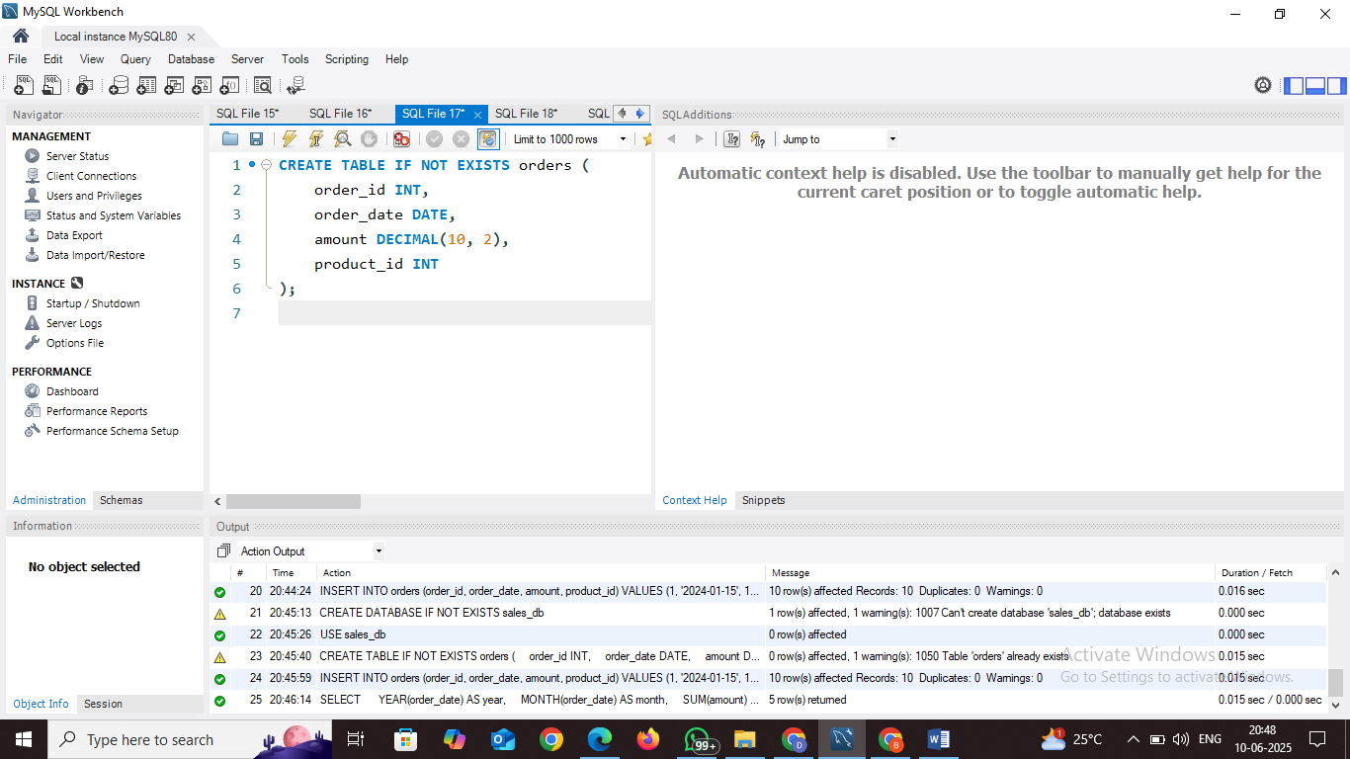

**Step 4: Insert Sample Data**

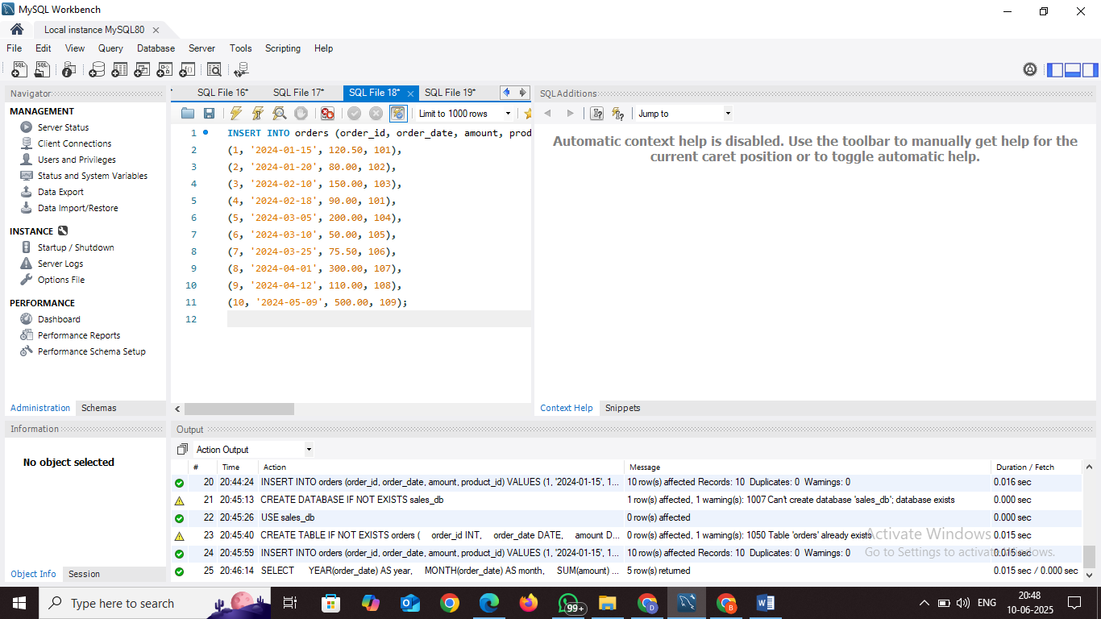

**Step 5: Run Sales Trend Analysis Query**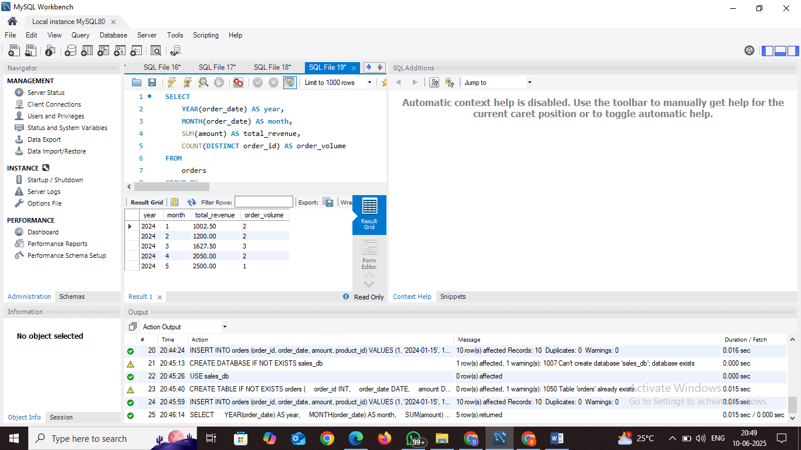

**k.dharmike**